

Travlr Getaways

CS 465 Project Software Design Document
Version 1.0

Table of Contents

CS 465 Project Software Design Document 1
Table of Contents 2
Document Revision History 2
Executive Summary 3
System Architecture View 5
Component Diagram 5
Class Diagram 8
API Endpoints 9
The User Interface 9

Document Revision History

Version | Date | Author | Comments
1.0 | 4/16/2026 | Victor Ngetich | Initial release of the Software Design Document for the Travlr Getaways full stack web application

Executive Summary
The Travlr Getaways web application is created based on MEAN stack (MongoDB, express, Angular, and Node.js) to provide a full-stack JavaScript web solution that can be scaled, maintained, and provide the functional requirements of a modern travel booking platform. This architecture was chosen since all the four layers have a common language (JavaScript) and therefore, there would be minimal context switching when it comes to development and there would be seamless flow of data between the database and the server to the client.
The app entails two front end experiences. Its customer-facing component is a server-rendered Express web application which allows the traveler to search and select the available trip packages, determine the trip details, and use the platform in a classic multi-page format. The Handlebars (HBS) templating engine generates pages dynamically on the server and transmits them to the browser as fully developed HTML, which works well with rapid initial page loads and easy navigation.
The administrator can also be described as a Single-Page Application (SPA) which is based on Angular. It is an interface only accessible to authorized personnel and offers a dynamic and responsive environment to manage the data of trips without the need to reload the page completely. Using Angular SPA, the SPA interacts directly with a RESTful API which is constructed using express and node.js to complete CRUD operations, which allow creating new trip listing, reading pre-existing records, updating trip information, and deleting old packages. MongoDB is a document-based, flexible persistence database and stores trip and user data, which is part of the stack and the mongoDB data is based on the JavaScript objects, thereby not requiring the layers to be linked to each other by complex data mapping.

Design Constraints

The design of the Travlr Getaways application is prone to various design constraints that influence the way the system will be designed and developed.
Technology Stack Requirement: The application should be developed with MEAN stack. It limits the environment of JavaScript and JSON development to all layers and, conversely, implies that the team must operate within the strengths and weaknesses of these frameworks. Indicatively, Express is a bare bones framework that must be enhanced with other middleware’s like authentication and input validation, which are supposed to be added intentionally, not automatically.
Single-Page Application Requirement: The administrator interface should be Angular SPA. Such an architectural choice enhances client responsiveness, as well as lowers server load by passing rendering tasks to the client browser. It, however, adds further complexity concerning the management of state, routing, and securing API calls, all of which should be thoroughly managed on the client’s side.
RESTful API Constraint: The interaction of all information between the Angular SPA and the back end should be conducted via a RESTful API. This implies that endpoints should be defined, stateless, and use of HTTP methods and status codes should be consistent. This limitation will facilitate a pure division of the front and back end; however, further API development and testing are necessary to guarantee reliability.
Authentication and Security Constraint: The access to the administrator SPA should be secured by JWT (JSON Web Token) authentication. This implies that every secured API route should authenticate the token before handling requests and the Angular front end should securely maintain token storage and transmission. Lack of this implementation puts the application at risk of data alteration that is not supposed to happen.
Database Constraint: MongoDB is utilized as a single data store. It is a NoSQL document database, defaulting to no strict schema, and provides flexibility in the development process, however, it needs to use Mongoose schemas to enforce data validation and consistency. To avoid incoherent records, all trip and user data should be in accordance with defined models of the Mongoose.
Deployment Constraint: The application is made and tested within a local node.js setup. This limits development process to make sure that all the dependencies are handled using npm and the application is portable between development machines without issues of environment specific configuration problems.

System Architecture View

Component Diagram
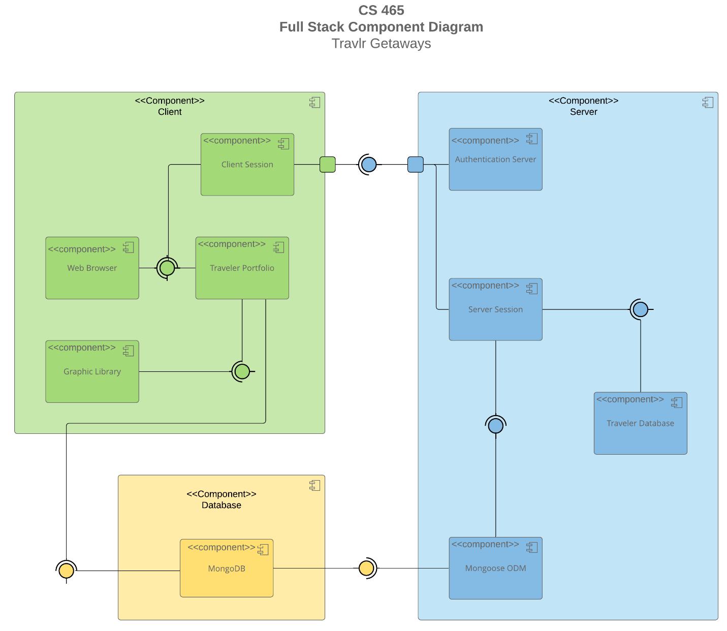
The component diagram has been provided in text version: CS 465 Full Stack Component Diagram Text Version.

The Travlr Getaways application is a three-tier designed application comprising of the presentation layer, application logic layer, and the data layer. The presentation layer has two different client interfaces: the customer facing Express web application and the Angular administrator SPA. These two interfaces are accessing the same middle tier the Node.js and Express server although in different ways. The application that is seen by the customer is rendered with HTML pages that are handled by the Handlebars templating engine, and the Angular SPA sends asynchronous HTTP requests to the restful API endpoints provided by the Express server.
All the application logic is implemented by Node.js and Express. Express is the web framework through which the incoming HTTP requests get routed, middleware used like authentication and body parsing, and the relevant responses are sent. Express router issues the API requests to respective controller functions that have the business logic of each operation.
The data layer comprises the MongoDB, which is supported by the Mongoose ODM (Object Document Mapper). Mongoose is used to define the schema definitions of Trip and User, and it ensures that data structure and validation is done before any document is written to the database. These Mongoose models are all that the Express server interacts with MongoDB, which guarantees a stable and predictable pattern of data access in the entire application.

Sequence Diagram
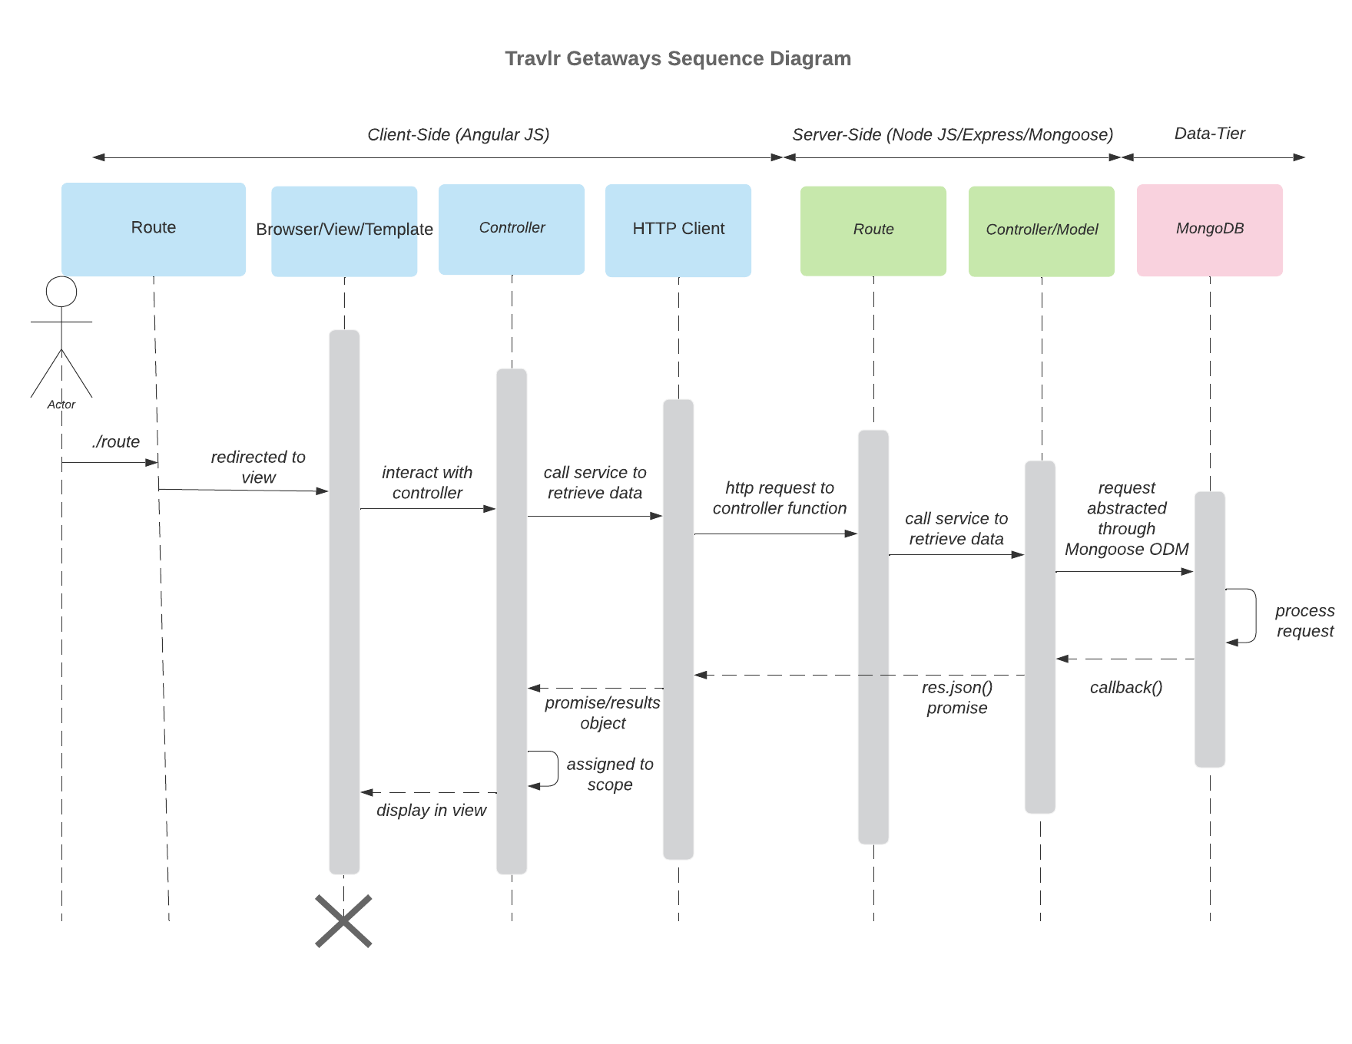
The sequence diagram illustrates the flow of logic through the Travlr Getaways web application across seven nodes, spanning three tiers: Client-Side (Angular JS), Server-Side (Node JS/Express/Mongoose), and Data-Tier.
The seven nodes from left to right are: Route, Browser/View/Template, Controller, and HTTP Client on the client side, Route, Controller/Model, and MongoDB on the server side and data tier.
The flow begins when an Actor navigates to./route, which is received by the client-side Route node. The Route redirects to the view, passing control to the Browser/View/Template node, which then interacts with the Controller. The Controller calls a service to retrieve data, forwarding the request to the HTTP Client, which sends an HTTP request to the server-side Route node. The server-side Route calls a service to retrieve data from the Controller/Model, which abstracts the request through Mongoose ODM to MongoDB. MongoDB processes the request and returns a callback to the Controller/Model, which resolves a res.json() promise back to the HTTP Client. The promise/results object is passed back to the Controller and assigned to scope, after which the Browser/View/Template node displays the data in the view, completing the request-response cycle.

Class Diagram
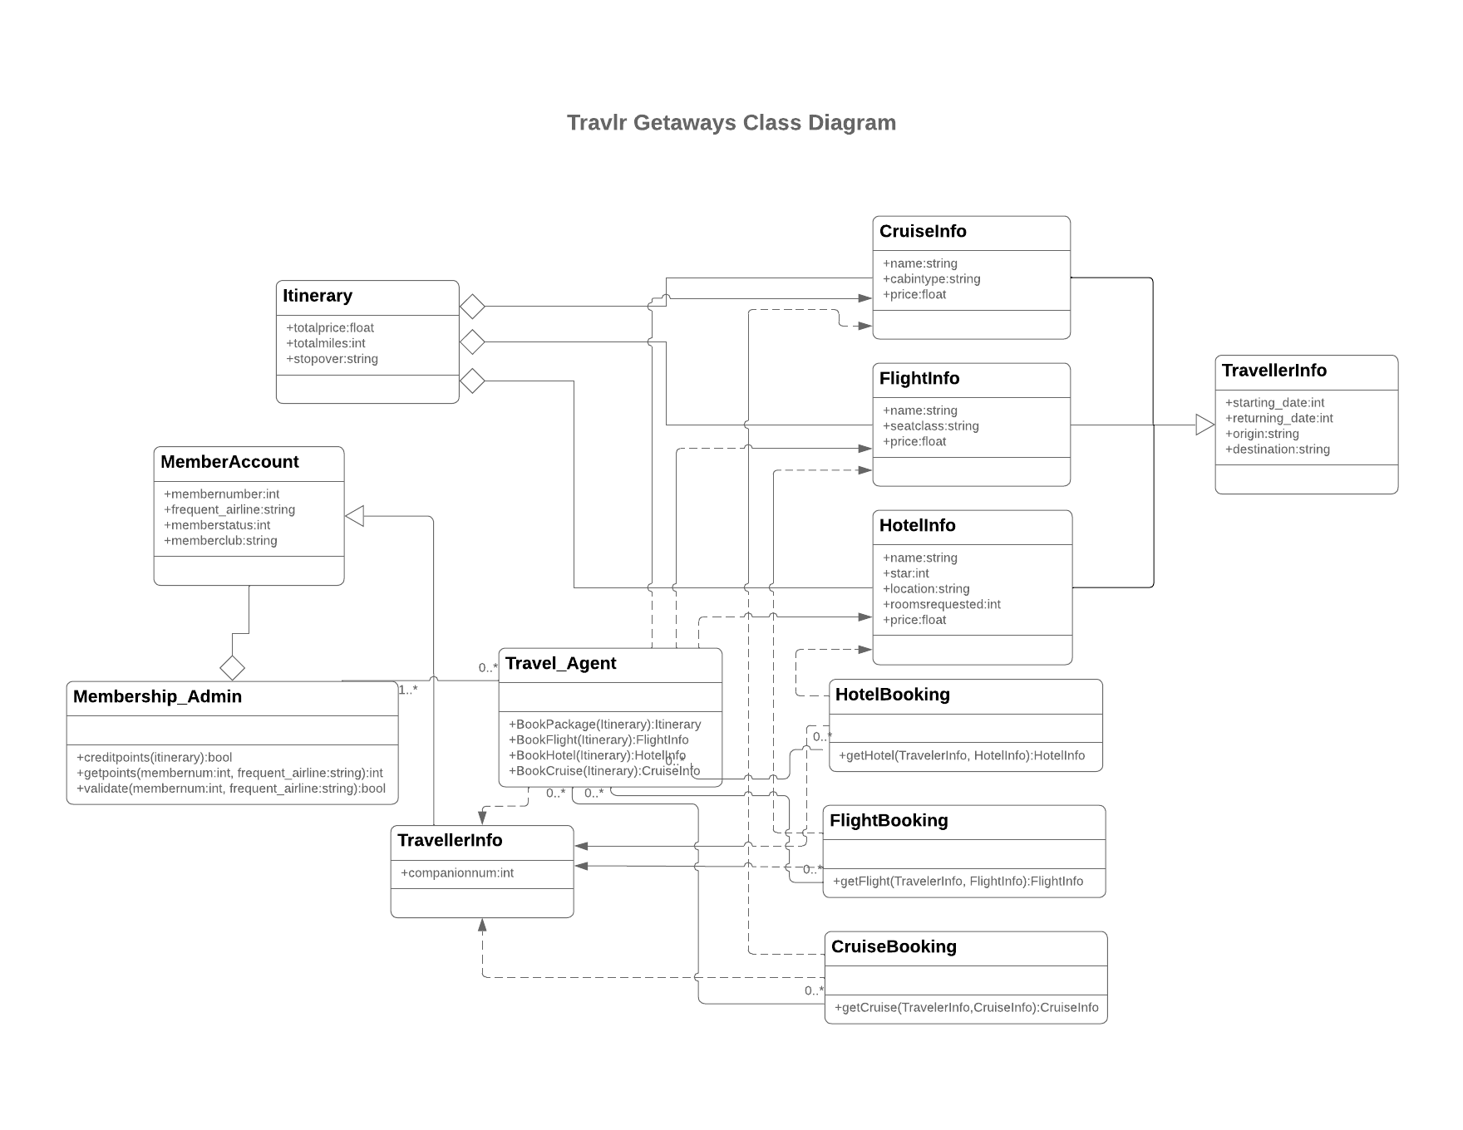

The class diagram illustrates the JavaScript classes that model the domain objects and relationships within the Travlr Getaways application.
At the core of the application is the Itinerary class, which aggregates the travel package and is composed of three diamond associations connecting to CruiseInfo, FlightInfo, and HotelInfo. These three classes store the specific details of each travel service cruise (name, cabin type, price), flight itineraries (name, seat class, price), and hotel accommodation (name, star rating, location, rooms requested, price) respectively.
The TravellerInfo class on the top right stores trip scheduling details including starting date, returning date, origin, and destination, and is associated with the Itinerary through a direct relationship.
On the user and account side, MemberAccount holds membership details including member number, frequent airline, member status, and member club. It has a composition relationship with Membership_Admin, which represents a privileged role and contains methods to validate credits, get points, and validate membership. Membership_Admin aggregates one or more Travel_Agent instances (1. *), which handles booking operations through four methods: BookPackage, BookFlight, BookHotel, and BookCruise.
The booking classes, HotelBooking, FlightBooking, and CruiseBooking, each link TravellerInfo to their corresponding service info class, with multiplicity of 0. * recording the transactional details of each reservation through getHotel, getFlight, and getCruise methods respectively.

API Endpoints
Method | Purpose | URL | Notes
GET | Retrieve list of all trips | /api/trips | Returns all trips (no auth)
GET | Retrieve single trip | /api/trips/:tripCode | Returns one trip (no auth)
POST | Create a new trip | /api/trips | Requires authentication
PUT | Update an existing trip | /api/trips/:tripCode | Requires authentication
DELETE | Delete a trip | /api/trips/:tripCode | Requires authentication
POST | User login/authentication | /api/login | Returns token
GET | Verify authenticated user | /api/profile | Requires authentication

The User Interface
- Added a unique trip
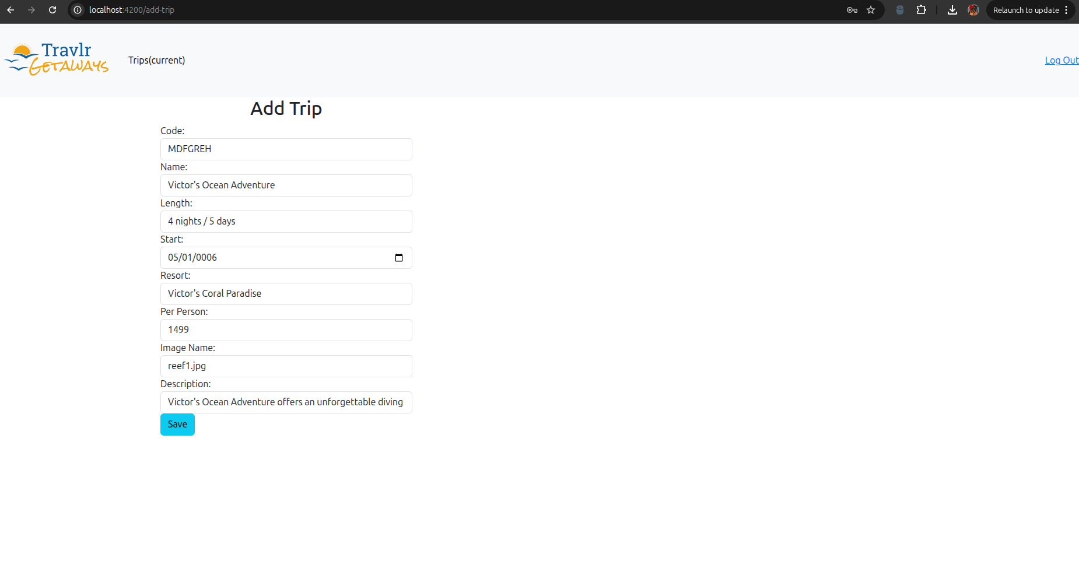

- screen shot showing the unique trip
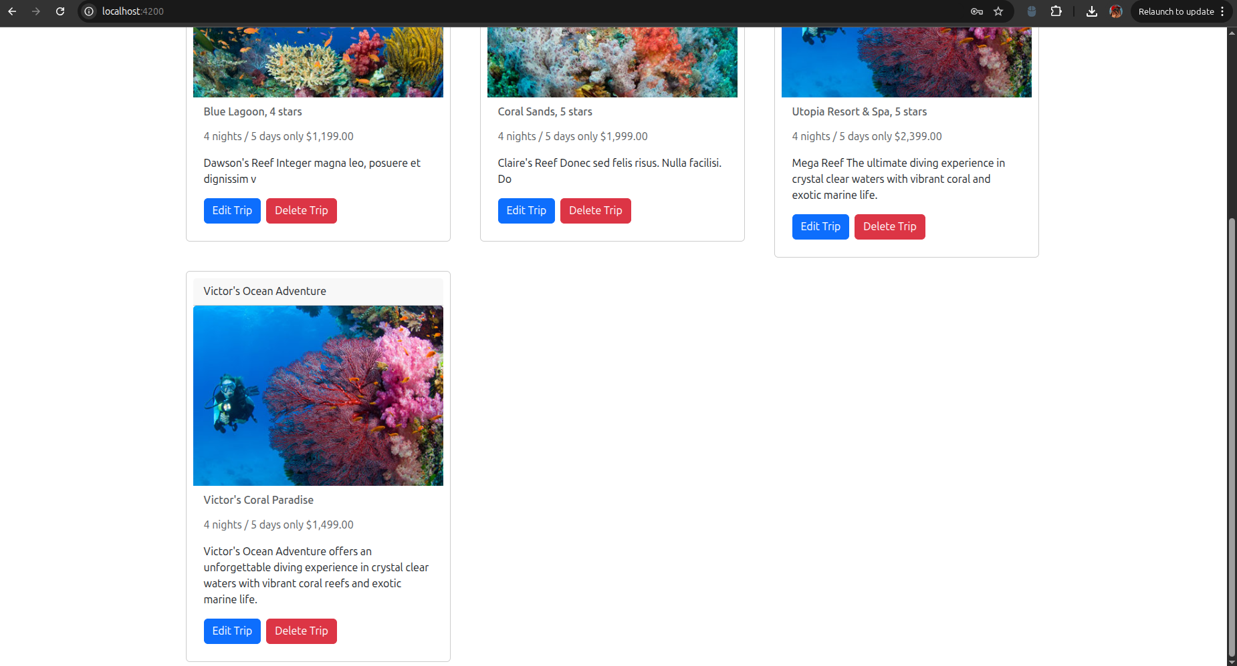
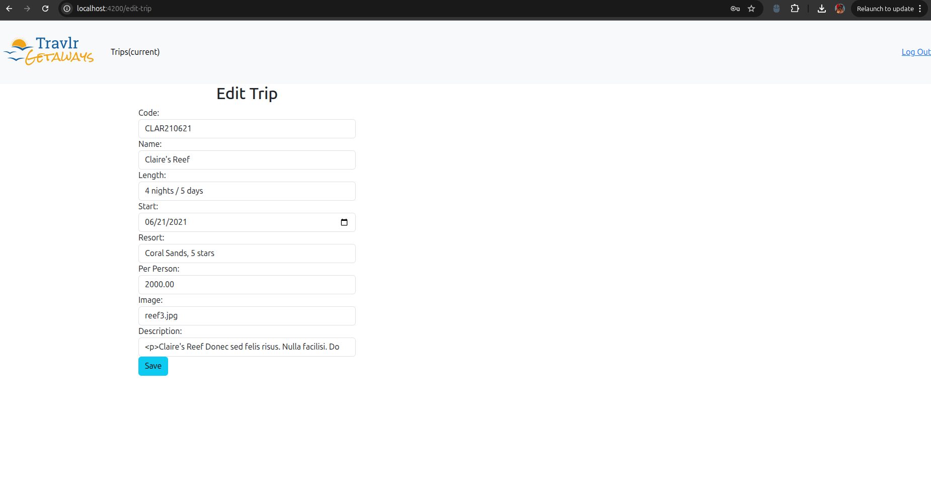
- updating a trip
- Updated the length and price for Claire's Reef
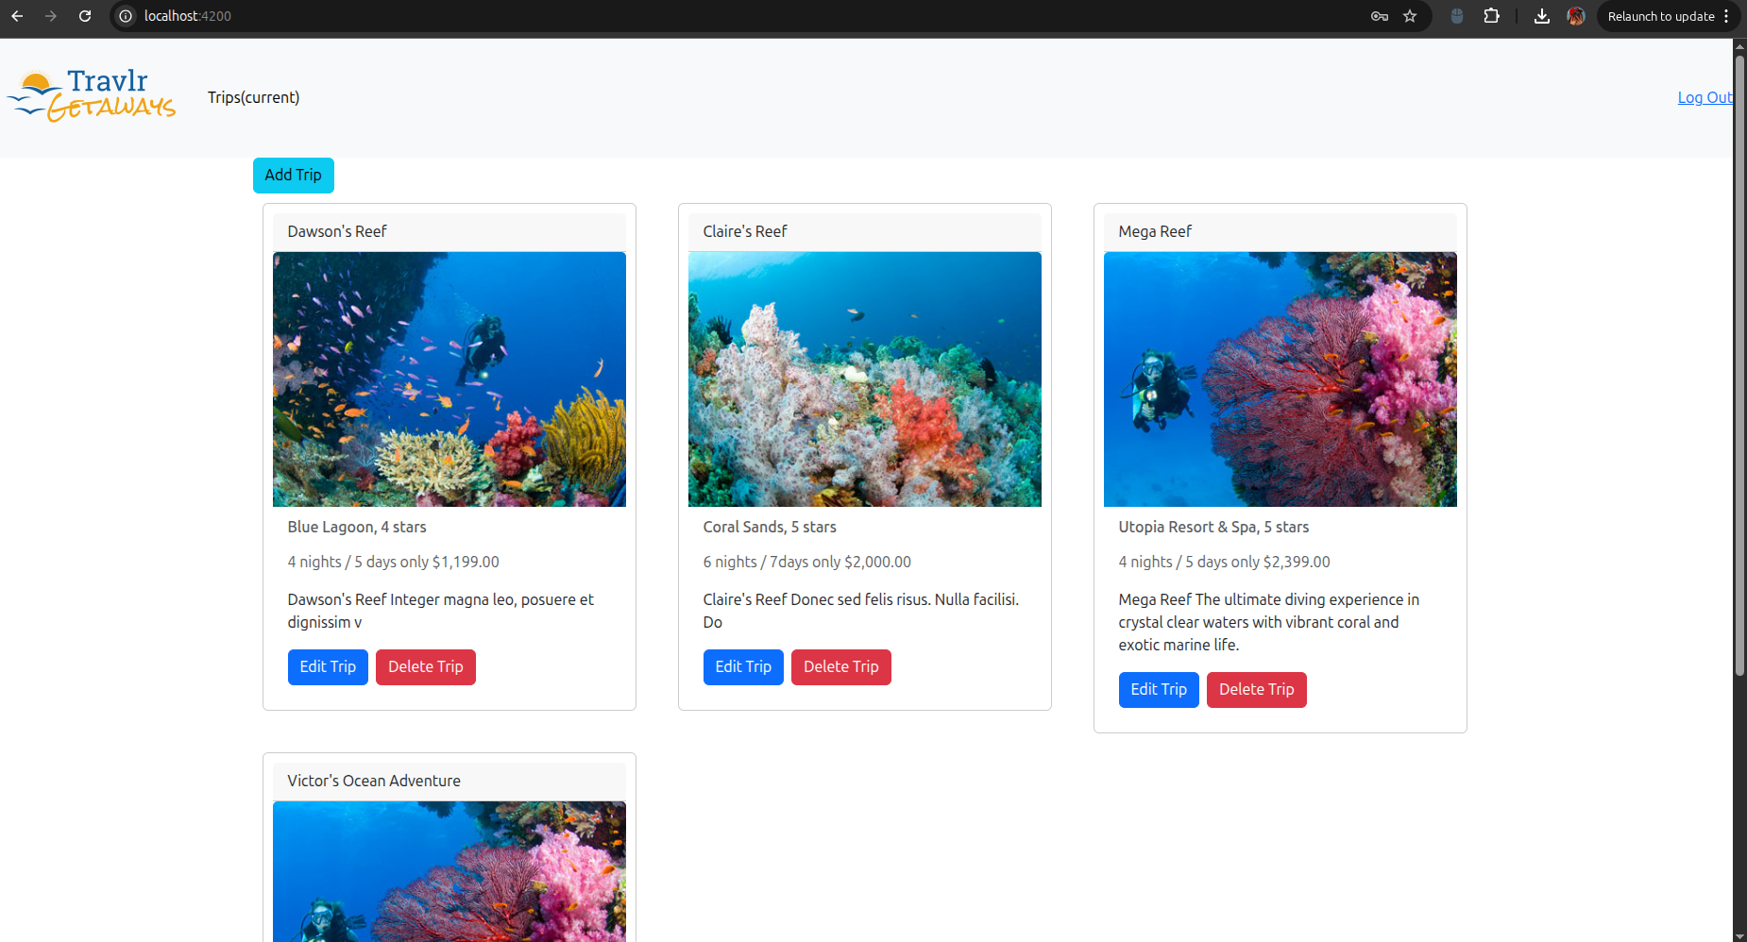

The Angular SPA and the Express customer-facing application have the same back-end API and data source, a significant difference being in the structure of projects and models of interaction. The Express application is structured in a Model-View-Controller (MVC) pattern, where routes are specified in a route’s directory, Handlebars templates are in a view’s directory, and controllers oversee the business logic between the two. Every user action causes a complete cycle of request-response interaction, and the server responds with an entire HTML page rendered to every interaction.
Angular project on the other hand is designed into components, services and modules. The components have a self-contained HTML template, CSS styling and TypeScript logic, which is encouraged in favor of reusability and separation of concerns. The TripDataservice performs as a single data access point which hides all HTTP communication and provides observable methods to which the components subscribe. The in-built router of Angular allows users to navigate the views without causing a page to reload, and this makes the SPA much more fluid and responsive to the user than the traditional multi-page Express application.
The customer-facing side of the SPA is much less rich than the one that provides functionality. Additions, updates, and viewing of new trip listing immediately can be done by the administrators without the need to leave the application or even wait until the entire page has been reloaded. Angular reactive forms are used to validate forms in real-time, and the user is notified immediately of any mistake committed in the form before even a request is dispatched to the server.
The SPA was tested through checking the GET as well as the PUT operations against the live API. To do GET operations, the trip list was loaded in the browser, and its contents were verified to be correct to the documents held in MongoDB using MongoDB Compass. In the PUT operations, an existing trip was modified using the Angular Edit form, which was then submitted, and finally, the updated trip list was reloaded, and the updated values were checked to be the correct ones. Each HTTP request and response was inspected in the browser developer tools Network tab and ensured that the appropriate endpoints were called, the JWT was present in the Authorization header, and the server responded with the 200-status code with the updated trip data.

